2.1 Novel Study

Mr Pip

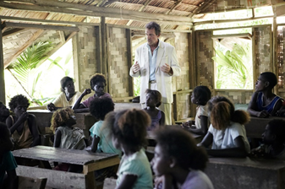

By Lloyd Jones

2.2 Analyse specified aspect(s) of studied written text(s),
supported by evidence
External Exam - 4 Credits

Ms Hames, 2017
Index Page
Plot Summary ……...………………………………………………………. 2
Plot - Timetable, beginning of novel………………...………………….… 3
Plot - Climax and Ending…………………………………………………...4
Setting………………………………………………………………………...4
Narrative Point of View……………………………………………………...4
Characters - Matilda.……………………………………………………….. 5
Characters - Mr Watts……………………………………………………… 6
Characters - Dolores……………………………………………………….. 7
Characters - your choice…………………………………………………... 8
Relationships and Conflicts between characters………………………...9
Conflicting Groups…………………………………………………………10
The Epigraph……………………………………………………………….10
Themes - the Power of Books and Words/Escapism…………………..11
Themes - Endurance………………………………………………………12
Themes - Courage………………………………………………………....13
Themes - Violence and the Fear of War…………………………………14
Themes - Good v Evil……………………………………………………...15
Symbolism - Colour………………………………………………………...16
Symbolism - The Island as the Garden of Eden………………………...17
Symbolism - God and the Devil…………………………………………...18
Language Style……………………………………………………………..19
Key Quotes……………………………………………………………...20-23
Your Key Quotes…………………………………………………………...23
Answering an Level 2 Essay Question…………………………………..24

“Characters Migrate.” Umberto Eco

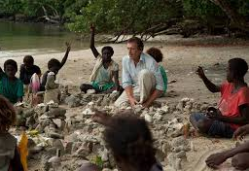
Plot
Record the main events for each chapter as they happen so you can refer to this later.

.

Plot Graph
The plot of any story usually builds up to one (or more) climax or turning point

Beginning and Ending of the Novel

How does the author set the scene at the beginning of the novel?
________________________________________________________________________________________________________________________________________________________________________________________________________________________________________________________________________________________________________________________________________________________________________

How are we introduced to the characters? Who are they?
________________________________________________________________________________________________________________________________________________________________________________________________________________________________________________________________________________________________

What important events occur at the beginning of the novel?
________________________________________________________________________________________________________________________________________________________________________________________________________________________________________________________________________________________________________________________________________________________________________

What is the Climax or Turning Point in the story? Is there more than one?
________________________________________________________________________________________________________________________________________________________________________________________________________________________________________________________________________________________________

How does the story end? Do you think this is a satisfying ending for Matilda? For the reader?
________________________________________________________________________________________________________________________________________________________________________________________________________________________________________________________________________________________________________________________________________________________________________

Setting (time and place)
What is the historical background to the setting of the novel?
________________________________________________________________________________________________________________________________________________________________________________________________________________________

We are transported back to Charles Dickens’ England - what does this setting provide to our story? ________________________________________________________________________________________________________________________________________________________________________________________________________________________

What roles do New Zealand and Australia play as settings in the novel?
________________________________________________________________________________________________________________________________________________________________________________________________________________________________________________________________________________________________

Narrative Point of View
Who is telling the story? Is she an emotional character? What is the effect on you, as the reader, of using this narrator?
________________________________________________________________________________________________________________________________________________________________________________________________________________________________________________________________________________________________________________________________________________________________________

Characters
- Matilda

Describe Matilda’s character | How does Great Expectations affect Matilda’s life?
At the beginning of the novel | At the middle | At the end of the novel
Quotes to describe Matilda’s character |  |  | Describe Matilda’s relationship with her mother
What does Matilda have to endure during the novel? How does she manage to endure?

How much does the novel Great Expectations play a part in Matilda’s life? How much does Mr Watts play a part? Explain how this relates to a theme/s.

Discussion Question
- What similarities does Matilda discover between her life and Pip’s?

Characters
2. Dolores (Matilda’s Mother)

Describe Dolores’s character | Describe her relationship with Matilda
Quotes to describe Dolores’ character |  | Describe her relationship with her husband
What part does religion play in her life? Relate this to themes and symbols in the novel.

What does Dolores have to endure during the novel? How does she manage to endure? Why is she so antagonistic towards Mr Watts?

Discussion questions:
- What is the meaning of the story of the Queen of Sheba? Why does Mr. Watts bring it up? Why is it significant that Dolores is familiar with that story?
- Why does Dolores step forward to declare herself “God’s witness” to the murder of Mr. Watts? Were you surprised that she did? Why does she insist that Matilda remain silent?
- What is the message Matilda’s mother is trying to express to the children with the story of her mother’s braids? How is this related to the issue of Mr. Watts’s faith in God?
- Who is Dolores warning the children about when she tells them the story about the devil lady and the church money? How does this story justify her actions regarding the book and the redskins? Do you agree with Dolores’s refusal to bring forth the book? With Matilda’s?

Characters
3. Mr Watts

Describe Mr Watts. | What do we know about his background?
Quotes to describe Mr Watts’ character |  | Describe his relationship with his wife, Grace
What does Mr Watts have to endure during the novel? How does he manage to endure? How much does the novel Great Expectations play a part? What does his relationship with his wife tell us about him?

Why does he tell the Redskins that he is Pip, and what does this tell us about him?

Discussion Questions:
- Is it important that Mr. Watts is the last white man on the island? Why?
- Why do you think Mr. Watts pulled his wife in the cart? Why did he wear the red clown nose? What meaning did that have for them?

Characters
4. Your chosen character _________________________________

Describe ____________. | What do we know about their background?
Quotes to describe their character |  | Important relationships
What does _______________ have to endure during the novel? Do they manage to endure? If not, what is their downfall? Other notes...

Relationships and Conflicts Between Characters
What are the parallels and contrasts between Matilda and Pip’s lives?
________________________________________________________________________________________________________________________________________________________________________________________________________________________________________________________________________________________________________________________________________________________________________

Describe the relationship/conflict between Matilda and her mother
________________________________________________________________________________________________________________________________________________________________________________________________________________________________________________________________________________________________

Describe the relationship/conflict between Matilda and Mr Watts
________________________________________________________________________________________________________________________________________________________________________________________________________________________________________________________________________________________________

Describe the relationship/conflict between Mr Watts and Grace
________________________________________________________________________________________________________________________________________________________________________________________________________________________

Describe the relationship between Matilda’s mother and father
________________________________________________________________________________________________________________________________________________________________________________________________________________________

What do you believe is the most important relationship in the novel? Explain why (relating it to themes and/or symbols, with quote/s):
________________________________________________________________________________________________________________________________________________________________________________________________________________________________________________________________________________________________________________________________________________________________________________________________________________________________________________________________________________________________________________________________________________________________________________________________________________________________________________________________________________________________________________________________________________________________________________________________________________________

Conflicting Groups
Describe these groups and their conflicts and how they contribute to our understanding of themes in the novel.

The Rebels v The Redskins
________________________________________________________________________________________________________________________________________________________________________________________________________________________

The Australian Mining Companies (White Australians)
________________________________________________________________________________________________________________________________________________________________________________________________________________________

The Villagers
________________________________________________________________________________________________________________________________________________________________________________________________________________________

What similar conflicts have we seen recently around the world?
________________________________________________________________________________________________________________________________________________________________________________________________________________________

Another conflict is old v new, represented by Matilda’s world and Pip’s Dickensian world
How does the author’s use of parallels between the two worlds emphasise the divide between old and new?
________________________________________________________________________________________________________________________________________________________________________________________________________________________________________________________________________________________________

The Epigraph
“Characters Migrate.” Umberto Eco
- What examples of migration, literally and metaphorically, do we see in the novel?
________________________________________________________________________________________________________________________________________________________________________________________________________________________________________________________________________________________________________________________________________________________________________________________________________________________________________________

Themes
1. The Power of books and words, allowing Escapism
Explain what this theme is:
Mr Pip shows how books can change lives. It opens windows to a new world where you can meet new people..._______________________________________________________________________
________________________________________________________________________________________________________________________________________________________________________________________________________________________

Pick five boxes to fill in below. You need to have at least one from each line filled in. Explain an aspect of the book that falls under that category that develops this theme.
 | 1 | 2 | 3
Events

Characters

Symbols

Discussion Questions
- What did you think of the lessons that the mothers of the children bring to the classroom? If you were the parent of a child in Matilda’s class, what lesson would you teach the children? What might your mother have taught the class?
- Discuss your memorable experiences of being read to as a child. What book made the greatest impact on your life? Did any book come to you at precisely the right time, the way Great Expectations was brought to Matilda?

Themes
2. Endurance
Explain what this theme is:
________________________________________________________________________
________________________________________________________________________________________________________________________________________________________________________________________________________________________________________________________________________________________________

Pick five boxes to fill in below. You need to have at least one from each line filled in. Explain an aspect of the book that falls under that category that develops this theme.

 | 1 | 2 | 3
Events

Characters

Symbols

Themes
3. Courage
Explain what this theme is:
__________________________________________________________________________________
________________________________________________________________________________________________________________________________________________________________________________________________________________________________________________________________________________________________

Pick five boxes to fill in below. You need to have at least one from each line filled in. Explain an aspect of the book that falls under that category that develops this theme.

 | 1 | 2 | 3
Events

Characters

Symbols

Themes
4. Violence and the Fear of War
Explain what this theme is:
________________________________________________________________________
________________________________________________________________________________________________________________________________________________________________________________________________________________________________________________________________________________________________

Pick five boxes to fill in below. You need to have at least one from each line filled in. Explain an aspect of the book that falls under that category that develops this theme.

 | 1 | 2 | 3
Events

Characters

Symbols

Discussion Question
- How do we see violence escalating during the novel?

Themes
5. Good v Evil
Explain what this theme is:
____________________________________________________________________________________________________________________________________________________________
________________________________________________________________________________________________________________________________________________

Who do you think most represents evil in the novel? Explain why.
________________________________________________________________________________________________________________________________________________________________________________________________________________________

Pick five boxes to fill in below. You need to have at least one from each line filled in. Explain an aspect of the book that falls under that category that develops this theme.

 | 1 | 2 | 3
Events

Characters

Symbols

Symbolism
A symbol is an object, person or place used within a text to represent an idea. They are often repeated for impact and can be called motifs.

Colour - black, white and blue

Link these colours to two characters and explain what idea it deepens for those characters.
Character 1 |  | Character 2
List three quotes/scenes that refer to these colours. Explain the significance of the colours in theses quotes/scenes.
Quote 1 | Quote 2 |  | Quote 3
Relate black/white/blue to two themes from the novel. How do they represent this theme?
Theme 1: |  | Theme 2:
What is the wider world significance of the colours black, white and blue? What are they associated with?

- See Pg 52 for more on the colour blue
Symbolism
The Island as The Garden of Eden

Link the symbol to two events and explain what idea it emphasises in the novel.
Event 1 |  | Event 2
List three quotes/scenes that include the island as like the Garden of Eden. Explain the significance of the description in theses quotes/scenes.
Quote 1 | Quote 2 |  | Quote 3
Relate the Garden of Eden to two themes from the novel. How does it represent this these themes?
Theme 1: |  | Theme 2:
What is the wider world significance of the Garden of Eden and the Bible? What are they associated with?

Symbolism
3. God and the Devil

Link references to God or the devil to two characters/groups and explain what idea it deepens for those characters.
Character 1 |  | Character 2
List three quotes/scenes that refer to God or the devil. Explain the significance of them in theses quotes/scenes.
Quote 1 | Quote 2 |  | Quote 3
Relate God/the devil two themes from the novel. How does he represent this theme?
Theme 1: |  | Theme 2:
What is the wider world significance of references to God and the devil? What are they associated with?

Language Style
(eg.,use of similes, metaphors, personification, alliteration, , etc.)

Quote | Type of language feature | Effect of using this feature

Key Quotes
Exploitation - The role of the white person
“She only saw a white man. And white men had stolen her husband and my father. White men were to blame for the mine, and the blockade. A white man had given us the name of our island. White men had given me my name. By now it was also clear that the white world had forgotten us”

"There were white people crawling over Panguna like ants over a corpse."

"Port Moresby was dependant on Australian aid which came in many forms - teachers, missionaries, canned fish, and even the helicopters used to drop the rebels out to sea."

‘White men were to blame for the mine and the blockade. A white man had given us the name of our island. White men had given me my name. By now it was also clear that white men had forgotten us.’

The Power of Books and Words/Escapism
"Mr. Watts had given us kids another world to spend the night in. We could escape to another place".

"I think Mr. Watts enjoyed the spoken parts. When he spoke them he became the voices. That's another thing that impressed us - for the time he was reading, Mr. Watts had a way of absenting himself. And we forgot all about him being there" .

"We had no books. We had our minds and we had our memories, and according to Mr. Watts, that's all we needed".

"What I didn't know at the time was all of us kids were carrying installments of Great Expectations back to our families".

“I had found a new friend. The surprising thing is where I’d found him – not up a tree or sulking in the shade, or splashing around in one of the hill streams, but in a book. No one had told us kids to look there for a friend. Or that you could slip inside the skin of another. Or travel to another place with marshes, and where, to our ears, the bad people spoke like pirates. ”

"It was always a relief to return to Great Expectations. It contained a world that was whole and made sense, unlike ours."

“We’ve all lost a lot in recent times. Those losses remind ourselves of the things we can never lose: our minds and our imaginations ... and our great expectations.”

"At some point I felt myself enter the story..I wasn't identifiable on the page, but I was there...I knew that orphaned white kid and that small, fragile place he squeezed into... because the same space came to exist between Mr. Watts and my mum. And I knew I would have to choose between the two."

"I knew things could change because they had for Pip...we learned how a life could change without any warning."
"These losses, severe though they may seem, remind us of what no person can take, and that is our minds and our imaginations." (Mr. Watts)

"Pip is an orphan who is given the chance to create his own self and destiny. Pip's experience reminds us of the emigrant's experience. Each is free to create himself anew. Each is also free to make mistakes..." (Mr. Watts)

“It gave me a friend in Pip. It taught me you can slip under the skin of another just as easily as your own, even when that skin is white and belongs to a boy alive in Dickens' England. Now, if that isn't an act of magic I don't know what is."

“My Mr. Dickens had taught every one of us kids that our voice was special, and we should remember this whenever we used it, and remember that whatever else happened to us in our lives our voice could never be taken away from you.”

Matilda and Dolores
"She didn't want me to go deeper into that other world. She worried she would lose her Matilda to Victorian England."

"Great Expectations came between us."

"Pop Eye should be teaching you kids proper behaviour," she said. "I want to know everything that happens in that book. You hear me, Matilda?"

Survival, Enduring War
“The redskins were going to choke the island and the rebels into submission.”

"When we needed a saviour, Mr Watts had filled that role. When the redskins required a life, Mr Watts had given himself."

"Now I knew fear as Pip had known it when Magwitch threatened to eat his heart and liver...I felt singled out by this darkness that had descended over our lives."

The waiting for the worst to happen is endless. It feels like a rehearsal for the ultimate and inevitable horror that has to come. They are trapped. There is no physical escape, only the escape into the world of the imagination.

‘This is what happens, you wait and wait. Until you wish the redskins would just come so that the waiting can be over.’

"You saw how disrespectful the sun could be, and how dumb the palms were to flutter back at the sea. The great shame of trees is that they have no conscience."

"We were being pecked at - the way a seabird will turn over a morsel of crab with its beak."

"Once more we saw what a strange fish had washed up on our shore."

"His soldiers followed like a pack of dogs after their masters."

"They came upon us like cats."

"I do not know what you are supposed to do with memories like these. It feels wrong to want to forget. Perhaps this is why we write these things down, so we can move on."

Colour
“We had grown up believing white to be the colour of all the important things like ice-cream, aspirin, ribbon, the moon, the stars...”

“According to us we are black as the night. The soldiers looked like people leached up out of the red earth.”

The dog’s name was Black….It was Black and his insides exposed to the harsh sun that we thought about.”

“White is next to cleanliness. Cleanliness is next to Godliness.”

“Above all, he said, white is a feeling.”

“We feel white around black people.”

“I miss the colour blue” (Grace)

‘Blue is the colour of the Pacific. It is the air we breathe. Blue is the gap in the air of all things, such as the palms and iron roofs. But for blue we would not see the fruit bats. Thank you God for giving us the colour blue.’

The Island as the Garden of Eden
“We had fish. We had our chickens. We had our fruits. We had what we always had. We had our pride".

“We played in the streams that tumble and spill down steep hillsides. We found new pools in which to look for our floating faces of mischief. We played in the seas and our black skins got blacker under the sun.”

“Bougainville is one of the most fertile places on earth. Drop a seed in the soils and three months later you are picking fruit.”

“We could see the beach palms spreading up to a blue sky. And a turquoise sea so still we hardly noticed it,”

God v The Devil / Good v Evil
“My mum...didn’t know anything outside of what she knew from the Bible.”

Dolores would have been pleased with Mr Watts’s explanation that ‘we know the devil because we know ourselves. And how do we know God? We know God because we know ourselves.’

‘And God said, Let there be light. And there was light. There is no sentence in the world more beautiful than that one.’
“Children, I have come to talk to you about faith”, she said, “You must believe in something. Yes, you must. Even the palm trees believe in the air.And the fish believe in the sea.”

“Faith is like oxygen. It keeps you afloat at all times.”
Your Key Quotes for the Exam

Page | Character | Quote | Significance

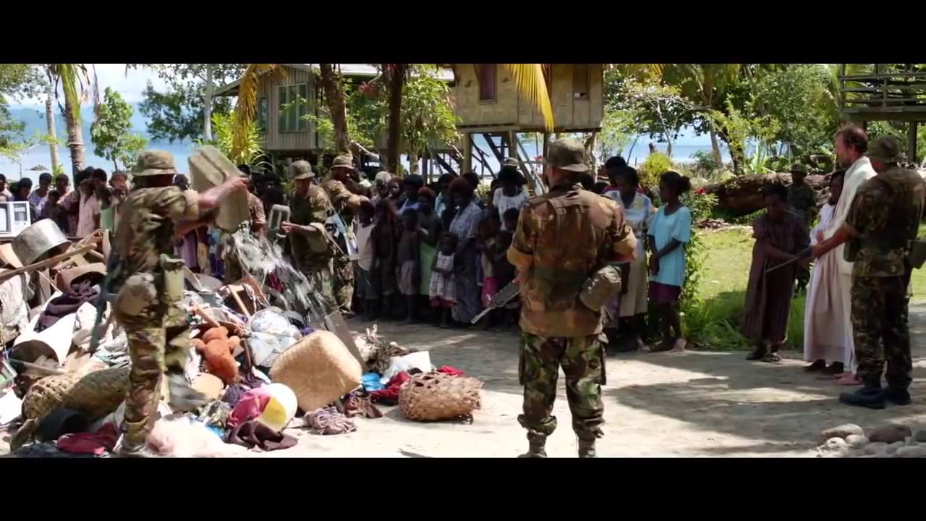

Answering a Level 2 Essay Question

What will the questions look like?
Usually the questions are one sentence with two parts, however, some questions may only have one part. The first part usually asks you to analyse how techniques or methods are used to present an aspect of the text. The second part usually asks you to give reasons as to why this aspect is effective (important, creates impact or influenced you) to the text as a whole. You must treat all parts of the question equally.

Answering a question
Choose a question that suits the text and targets what you have studied.
Underline keywords – these words will point to the sections of your study notes you need to use in your answer. Think of other words that mean the same so you have a group of useful words to use in your answer. See the sites Understanding the question and Understanding essay topics.

Plan – brainstorm and organise evidence
Brainstorm your main ideas using the keywords from the question to get your main idea. Sum up your angle or point of view in a statement or a challenging question. Brainstorm five solid points to help expand on your main idea. Select relevant material to support each point and develop your argument.

Outline of an essay plan
- Begin with a quotation, question, thesis statement, or opinion to sum up the question
- Focus on 4–5 connected key points, supported by relevant examples and analysis
- Develop a logical argument or explanation for each point
- Conclude by reinforcing a main idea from your thesis statement.

Paragraphs
A standard paragraph will organise your thoughts and have these things:
topic sentence
- stating the main idea to be developed within the paragraph
- use keyword from the question explanation
- expanding the idea through discussion evidence and detail
- quotations examples, and details to illustrate the idea should be woven into your sentence
- link back to the question by using keywords to answer the question.

Self-review
Use a checklist such as:
✔ Have I answered both parts of the question?
✔ How well does my evidence support my point of view?
✔ Is my personal response meaningful?

